Senior Design Team 1: Optical (Laser) Communications Low-Cost Payload

*Project description:*

NASA considers optical communications as the emerging technology of choice to enable high-data rate deep space wireless communications. Laser communication systems can achieve data rates beyond 100s of Gbps with payload size, weight, and power typically lower than traditional microwave systems. This team will work on the design, fabrication, and demonstration of a low-cost optical communications system to be used on small-satellite payloads. Software challenges include coding onboard computers for sensor data acquisition and transmission. Hardware challenges include the design and fabrication of a laser diode-based transmitter, a sensor receiver, and a laser pointing mechanism. The team will use commercial of-the-shelf components and a few custom-made PCBs to realize this system.

The high-level requirements of the system are the following:

* The system shall have a sensor that generates the data to be transmitted, for example, an optical camera.
* The system shall take the measured data and generate a modulated communication signal using an onboard computer that is then connected to a laser diode driver and then to a laser diode, which serves as the optical transmitter.
* The optical beam generated by the laser diode shall be pointing by a 2-axis pointing mechanisms to search for the receiver.
* The system should have a receiver comprised of an optical sensor that is then read by an onboard computer.
* The system should have a display that shows displays the measured data (e.g., video feed from the transmitter) and simultaneously save the data on the onboard memory.
* The system should be powered by batteries.

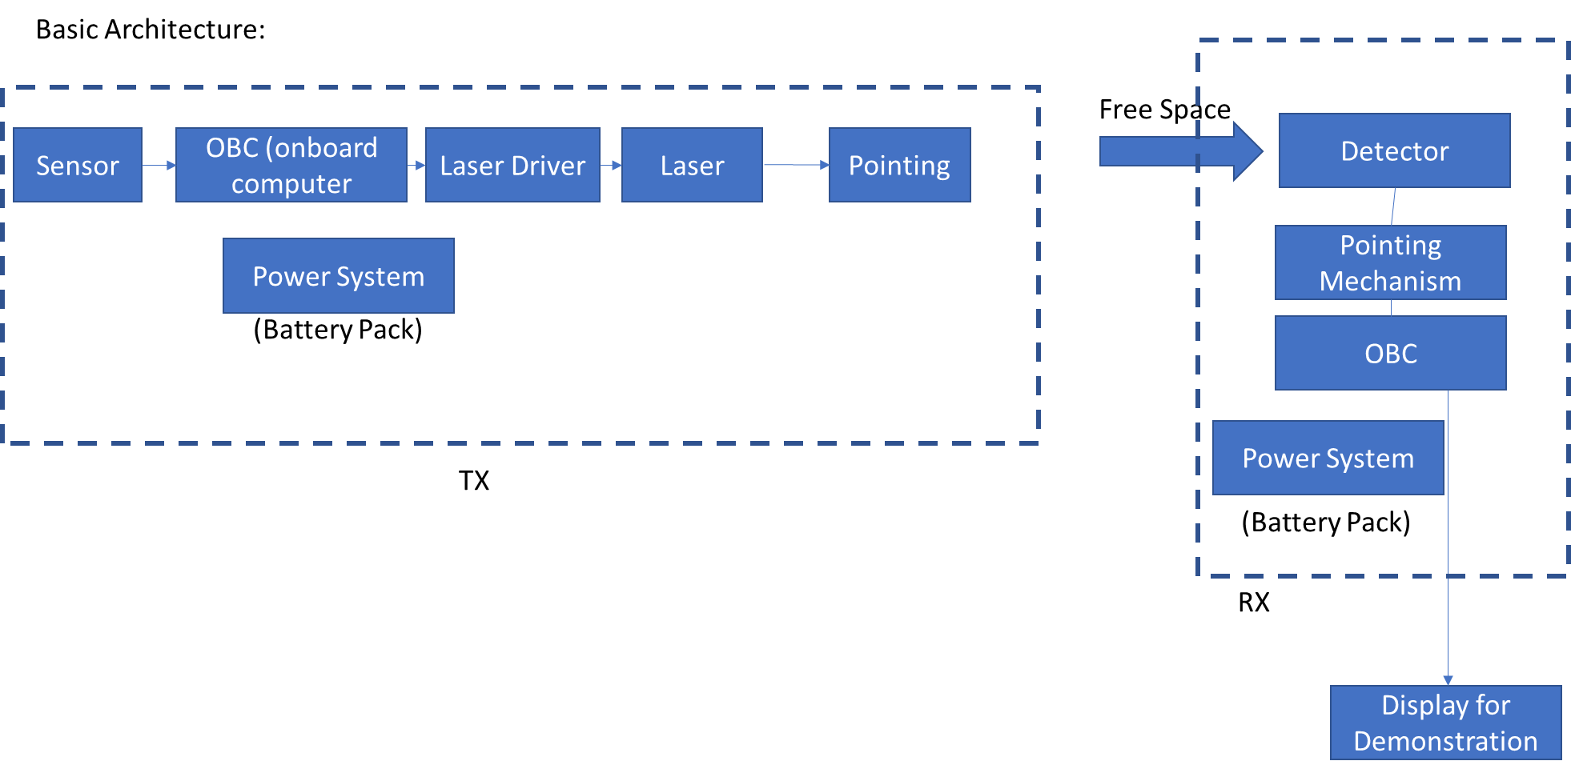

Initial Backlog Items (**not in order**):

* Understand all the materials, designs, devices, from Zhou Banga’s paper and the senior design team from last year.
* Get access to Micaplex 224 (sign lab policies form, get access from Dr. Rojas).
* Review literature on low-cost optical systems and confirm performance metrics.
* Review sensors of interest (optical camera)
* Check existing pointing mechanism, and how to operate it.
* Describe in detail the overall system architecture down to voltage and current levels, Digital I/O, Analog I/O, battery voltages, computer and Sensor interface.
* Review laser driver and detector configuration, perform basic performance tests.
* Identify and order items required for the overall system architecture. Check existing items.
* Design the power system, including batteries and voltage converters as needed.
* Design, or adjust existing design, the optical system using Keysight PDS.
* Implement pointing system for TX.
* Write codes for containing sensor data, process, and generate the OOK signal.
* Write codes for demodulating the OOK signal on the TX side.
* Integrate and test the TX and RX sub-systems.
* Design a packaging solution for the entire system, using additive manufacturing.
* Integrate and test the entire subsystem.